**SuperSet Id: 6376594**

React(Hands-On)

**Exercise-9:**

App.js Code:

import React from "react";

import ListofPlayers from "./components/ListofPlayers";

import IndianPlayers from "./components/IndianPlayers";

export default function App() {

  // Change this flag to see different outputs

  const flag = true; // true = ListofPlayers, false = IndianPlayers

  return (

    <div style={{ fontFamily: "sans-serif", padding: 16 }}>

      <h1>cricketapp</h1>

      {flag ? <ListofPlayers /> : <IndianPlayers />}

    </div>

  );

}

ListOfPlayers.jsx code:

import React from "react";

export default function ListofPlayers() {

  const players = [

    { name: "Rohit Sharma", score: 85 },

    { name: "Shubman Gill", score: 62 },

    { name: "Virat Kohli", score: 47 },

    { name: "Shreyas Iyer", score: 73 },

    { name: "Suryakumar Yadav", score: 39 },

    { name: "KL Rahul", score: 95 },

    { name: "Hardik Pandya", score: 67 },

    { name: "Ravindra Jadeja", score: 71 },

    { name: "R. Ashwin", score: 28 },

    { name: "Jasprit Bumrah", score: 14 },

    { name: "Kuldeep Yadav", score: 52 }

  ];

  const below70 = players.filter(p => p.score < 70);

  return (

    <section>

      <h2>List of Players (ES6 map)</h2>

      <ul>

        {players.map(({ name, score }, idx) => (

          <li key={idx}>

            <strong>{name}</strong> — Score: {score}

          </li>

        ))}

      </ul>

      <h3>Scores &lt; 70 (Arrow Functions)</h3>

      <ul>

        {below70.map(({ name, score }, idx) => (

          <li key={idx}>

            {name} — {score}

          </li>

        ))}

      </ul>

    </section>

  );

}

IndianPlayers.jsx Code:

import React from "react";

export default function IndianPlayers() {

  const indianPlayers = [

    "Rohit Sharma", "Shubman Gill", "Virat Kohli", "Shreyas Iyer",

    "KL Rahul", "Hardik Pandya", "Ravindra Jadeja", "R. Ashwin",

    "Jasprit Bumrah", "Mohammed Shami", "Kuldeep Yadav"

  ];

  const splitTeams = (arr) => {

    const oddTeam = [];

    const evenTeam = [];

    arr.forEach((name, idx) => {

      (idx + 1) % 2 === 1 ? oddTeam.push(name) : evenTeam.push(name);

    });

    return { oddTeam, evenTeam };

  };

  const { oddTeam, evenTeam } = splitTeams(indianPlayers);

  const t20Players = ["Rohit Sharma", "Suryakumar Yadav", "Hardik Pandya", "Ravindra Jadeja", "Jasprit Bumrah"];

  const ranjiPlayers = ["Prithvi Shaw", "Sarfaraz Khan", "Abhimanyu Easwaran", "Priyank Panchal", "Jalaj Saxena"];

  const mergedAll = [...t20Players, ...ranjiPlayers];

  const [captain, viceCaptain, ...restT20] = t20Players;

  return (

    <section>

      <h2>Indian Players (Destructuring + Merge)</h2>

      <h3>Odd Team Players</h3>

      <ul>

        {oddTeam.map((p, i) => (

          <li key={`odd-${i}`}>{p}</li>

        ))}

      </ul>

      <h3>Even Team Players</h3>

      <ul>

        {evenTeam.map((p, i) => (

          <li key={`even-${i}`}>{p}</li>

        ))}

      </ul>

      <h3>Merged Players (T20 + Ranji)</h3>

      <ul>

        {mergedAll.map((p, i) => (

          <li key={`merged-${i}`}>{p}</li>

        ))}

      </ul>

      <h3>Array Destructuring Example</h3>

      <p>Captain: {captain} | Vice-Captain: {viceCaptain}</p>

      <p>Rest Players: {restT20.join(", ")}</p>

    </section>

  );

}

Output:

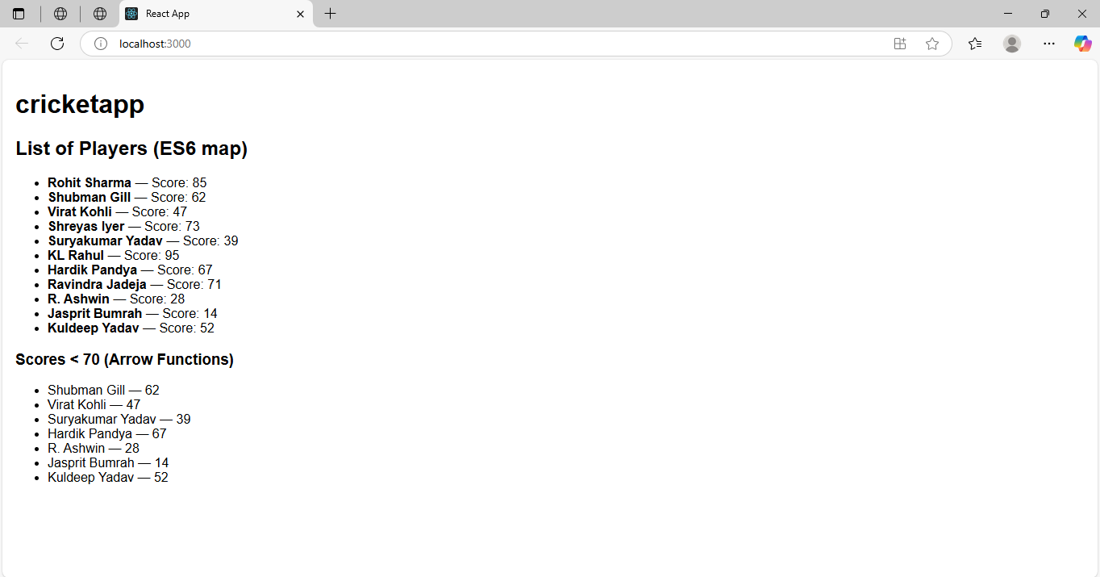

**Exercise-10:**

App.js Code:

import React from 'react';

import './App.css';

function App() {

  // Office data

  const offices = [

    {

      id: 1,

      name: 'Tech Park Office',

      rent: 55000,

      address: 'Koramangala, Bangalore',

      image: 'https://goyalco.com/wp-content/uploads/2021/10/tech-gallery-2.jpg'

    },

    {

      id: 2,

      name: 'City Center Hub',

      rent: 75000,

      address: 'MG Road, Bangalore',

      image: 'https://content.jdmagicbox.com/v2/comp/bangalore/y3/080pxx80.xx80.180411130337.y8y3/catalogue/city-centre-gandhi-nagar-bangalore-shopping-centres-cr5z77vcm6.jpg'

    },

    {

      id: 3,

      name: 'Startup Zone',

      rent: 60000,

      address: 'HSR Layout, Bangalore',

      image: 'https://i.guim.co.uk/img/media/8a2534df34e7da00763c4aab3b14259b7ad99f33/0_64_3000_1800/master/3000.jpg?width=465&dpr=1&s=none&crop=none'

    }

  ];

  // JSX to return

  return (

    <div className="App">

      <h1>🏢 Office Space Rental App</h1>

      {offices.map(office => (

        <div key={office.id} style={{ border: '1px solid #ccc', padding: '10px', margin: '10px' }}>

          <h2>{office.name}</h2>

          <img src={office.image} alt={office.name} style={{ width: '300px', height: '200px' }} />

          <p><strong>Address:</strong> {office.address}</p>

          <p>

            <strong>Rent:</strong>{' '}

            <span style={{ color: office.rent > 60000 ? 'green' : 'red' }}>

              ₹{office.rent}

            </span>

          </p>

        </div>

      ))}

    </div>

  );

}

export default App;

App.css Code:

.App {

  text-align: center;

  font-family: Arial, sans-serif;

  padding: 20px;

}

Output:

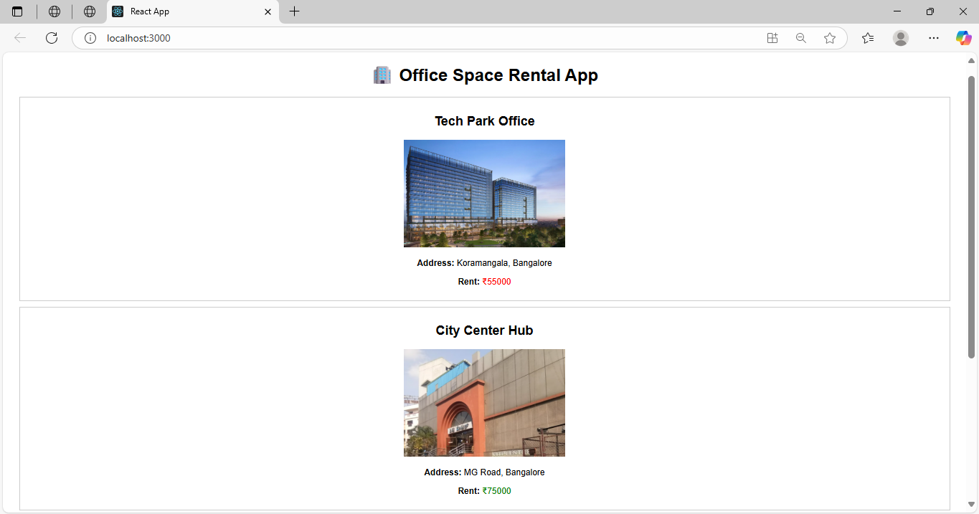

**Exercise-11:**

App.js Code:

import React, { useState } from 'react';

import CurrencyConvertor from './CurrencyConvertor';

function App() {

  const [count, setCount] = useState(0);

  const increment = () => {

    setCount(count + 1);

    sayHello(); // multiple function call

  };

  const decrement = () => {

    setCount(count - 1);

  };

  const sayHello = () => {

    console.log("Hello! This is a static message.");

  };

  const sayWelcome = (msg) => {

    alert(msg);

  };

  const handleSyntheticEvent = (e) => {

    e.preventDefault();

    alert("I was clicked");

  };

  return (

    <div style={{ padding: "20px" }}>

      <h1>React Events Example</h1>

      <h2>Counter: {count}</h2>

      <button onClick={increment}>Increment</button>

      <button onClick={decrement} style={{ marginLeft: "10px" }}>Decrement</button>

      <div style={{ marginTop: "20px" }}>

        <button onClick={() => sayWelcome("Welcome!")}>Say Welcome</button>

      </div>

      <div style={{ marginTop: "20px" }}>

        <button onClick={handleSyntheticEvent}>OnPress (Synthetic Event)</button>

      </div>

      <div style={{ marginTop: "30px" }}>

        <CurrencyConvertor />

      </div>

    </div>

  );

}

export default App;

CurrencyConvertor.js Code:

import React, { useState } from 'react';

function CurrencyConvertor() {

  const [inr, setInr] = useState('');

  const [euro, setEuro] = useState(null);

  const convertToEuro = (e) => {

    e.preventDefault();

    const result = parseFloat(inr) / 90; // example rate: ₹90 = €1

    setEuro(result.toFixed(2));

  };

  return (

    <div>

      <h2>Currency Convertor (INR to Euro)</h2>

      <form onSubmit={convertToEuro}>

        <input

          type="number"

          value={inr}

          placeholder="Enter amount in INR"

          onChange={(e) => setInr(e.target.value)}

        />

        <button type="submit" style={{ marginLeft: "10px" }}>Convert</button>

      </form>

      {euro !== null && <p>Converted amount: €{euro}</p>}

    </div>

  );

}

export default CurrencyConvertor;

Output:

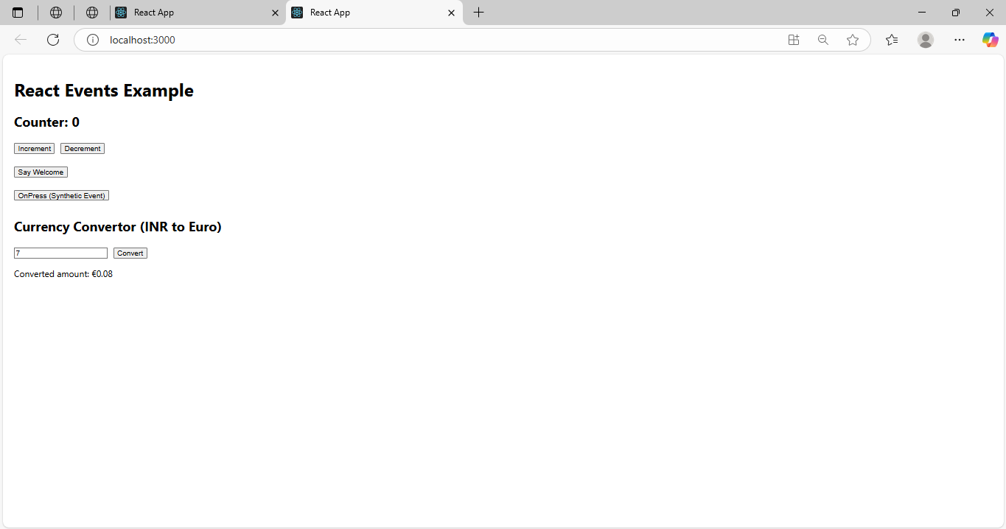

**Exercise-12:**

App.js Code:

import React, { useState } from 'react';

function App() {

  const [isLoggedIn, setIsLoggedIn] = useState(false);

  const handleLogin = () => {

    setIsLoggedIn(true);

  };

  const handleLogout = () => {

    setIsLoggedIn(false);

  };

  // Conditional Rendering using variable

  let content;

  if (isLoggedIn) {

    content = <UserPage onLogout={handleLogout} />;

  } else {

    content = <GuestPage onLogin={handleLogin} />;

  }

  return (

    <div style={{ padding: '20px', fontFamily: 'Arial' }}>

      <h1>✈️ Ticket Booking App</h1>

      {content}

    </div>

  );

}

function GuestPage({ onLogin }) {

  return (

    <div>

      <h2>Welcome, Guest!</h2>

      <p>Here are today's flight details:</p>

      <ul>

        <li>Flight AI-202 | Chennai to Delhi | 10:00 AM</li>

        <li>Flight AI-305 | Mumbai to Bangalore | 2:00 PM</li>

        <li>Flight AI-101 | Hyderabad to Kolkata | 6:30 PM</li>

      </ul>

      <button onClick={onLogin}>Login to Book</button>

    </div>

  );

}

function UserPage({ onLogout }) {

  return (

    <div>

      <h2>Welcome Back, User!</h2>

      <p>You can now book your tickets below:</p>

      <button>Book Ticket</button>

      <br /><br />

      <button onClick={onLogout}>Logout</button>

    </div>

  );

}

export default App;

Output:

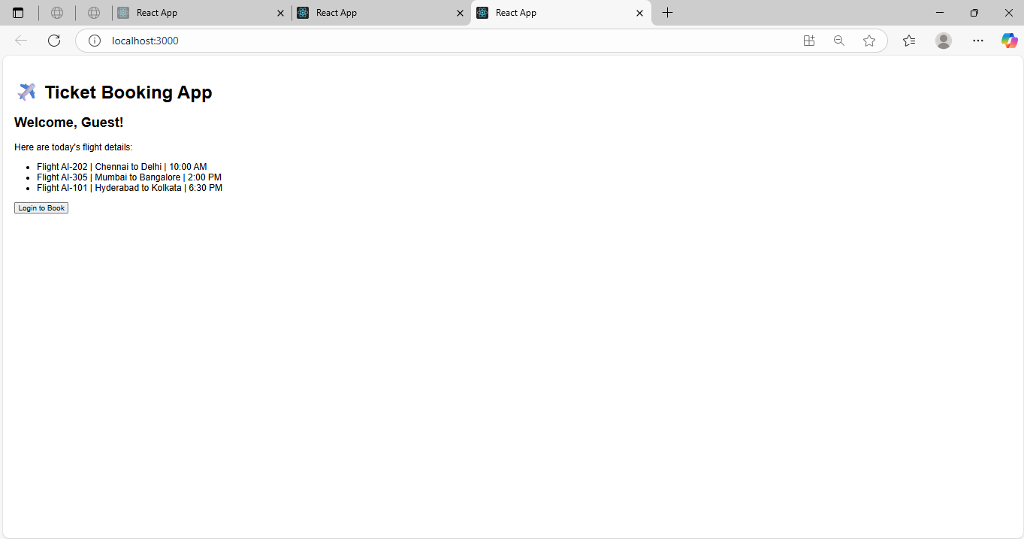

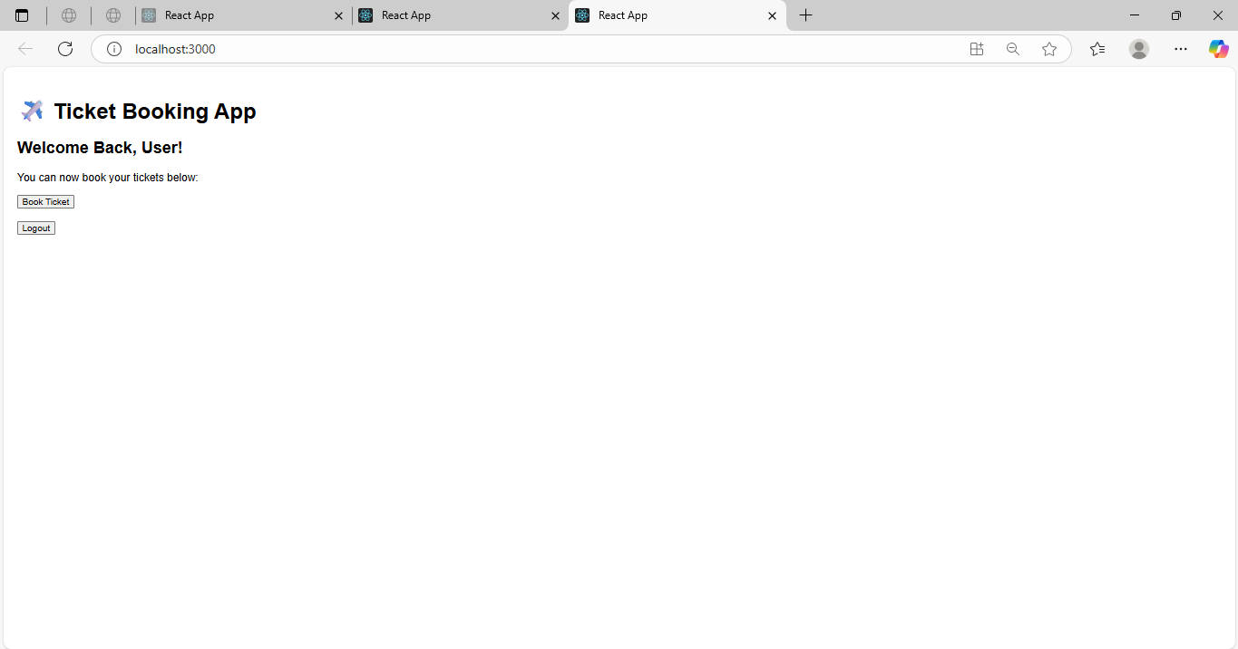

**Exercise-13:**

App.js Code:

import React, { useState } from 'react';

function App() {

  const [view, setView] = useState("book");

  const bookList = [

    { id: 1, title: "React Basics", author: "Dan Abramov" },

    { id: 2, title: "Learning JavaScript", author: "Kyle Simpson" },

  ];

  const blogList = [

    { id: 1, title: "React vs Angular", date: "2024-10-01" },

    { id: 2, title: "10 Tips for JS Devs", date: "2024-11-15" },

  ];

  const courseList = [

    { id: 1, name: "React Fullstack", duration: "3 months" },

    { id: 2, name: "Node.js Backend", duration: "2 months" },

  ];

  // Element variable conditional rendering

  let displayComponent;

  if (view === "book") {

    displayComponent = <BookDetails books={bookList} />;

  } else if (view === "blog") {

    displayComponent = <BlogDetails blogs={blogList} />;

  } else {

    displayComponent = <CourseDetails courses={courseList} />;

  }

  return (

    <div style={{ padding: '20px', fontFamily: 'Arial' }}>

      <h1>📘 Blogger App</h1>

      <div>

        <button onClick={() => setView("book")}>Show Book Details</button>

        <button onClick={() => setView("blog")} style={{ marginLeft: '10px' }}>Show Blog Details</button>

        <button onClick={() => setView("course")} style={{ marginLeft: '10px' }}>Show Course Details</button>

      </div>

      <hr />

      {displayComponent}

    </div>

  );

}

// Logical && rendering with map() and keys

const BookDetails = ({ books }) => (

  <div>

    <h2>📚 Book Details</h2>

    {books.length > 0 && books.map(book => (

      <div key={book.id}>

        <p><strong>Title:</strong> {book.title}</p>

        <p><strong>Author:</strong> {book.author}</p>

        <hr />

      </div>

    ))}

  </div>

);

// Ternary operator rendering

const BlogDetails = ({ blogs }) => (

  <div>

    <h2>📝 Blog Details</h2>

    {blogs.length > 0 ? blogs.map(blog => (

      <div key={blog.id}>

        <p><strong>Title:</strong> {blog.title}</p>

        <p><strong>Date:</strong> {blog.date}</p>

        <hr />

      </div>

    )) : <p>No Blogs Found</p>}

  </div>

);

// Inline if with logical && operator

const CourseDetails = ({ courses }) => (

  <div>

    <h2>🎓 Course Details</h2>

    {courses.length && courses.map(course => (

      <div key={course.id}>

        <p><strong>Name:</strong> {course.name}</p>

        <p><strong>Duration:</strong> {course.duration}</p>

        <hr />

      </div>

    ))}

  </div>

);

export default App;

Output:

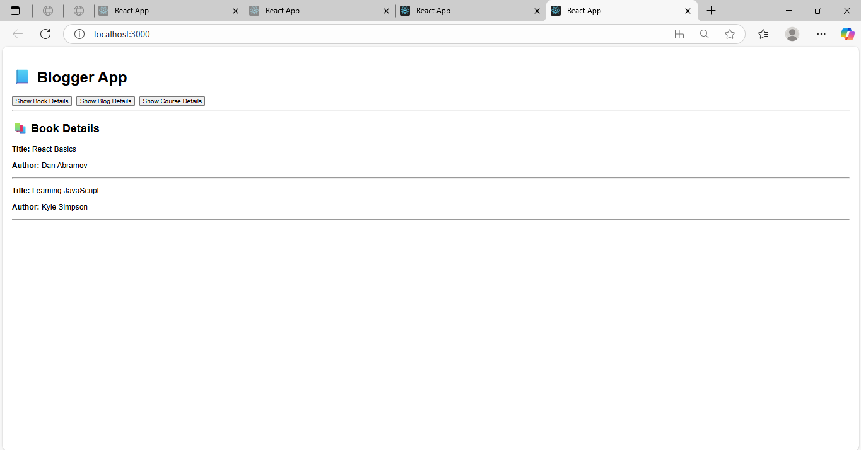

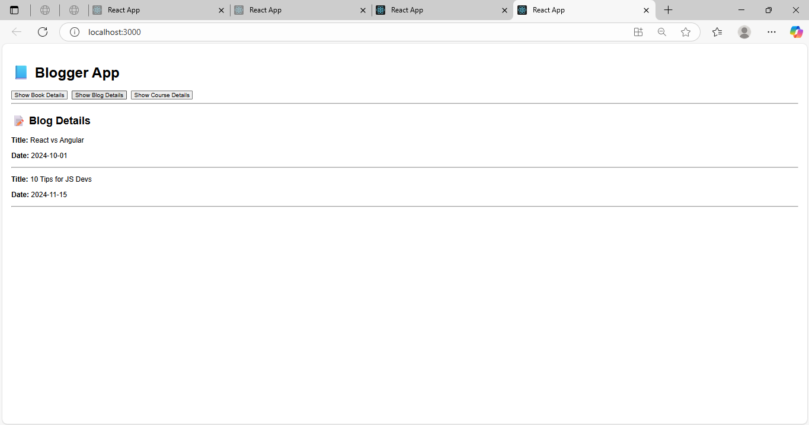

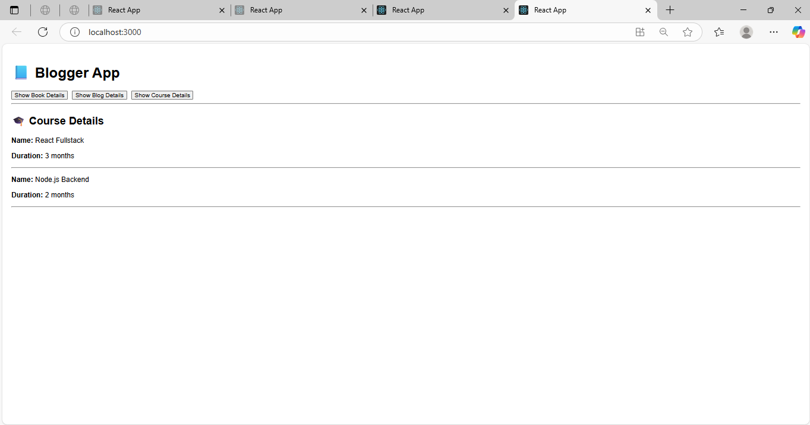

**Additional Exercises:**

**Exercise-14:**

App.js Code:

// src/App.js

import React, { useState } from "react";

import EmployeesList from "./EmployeesList";

import ThemeContext from "./ThemeContext";

function App() {

  const [theme, setTheme] = useState("light");

  const toggleTheme = () => {

    setTheme((prev) => (prev === "light" ? "dark" : "light"));

  };

  return (

    <ThemeContext.Provider value={theme}>

      <div>

        <h1>Employee Management App</h1>

        <button onClick={toggleTheme}>Toggle Theme</button>

        <EmployeesList />

      </div>

    </ThemeContext.Provider>

  );

}

export default App;

ThemeContest.js Code:

// src/ThemeContext.js

import { createContext } from "react";

const ThemeContext = createContext("light"); // default value

export default ThemeContext;

EmployeeList.js Code:

// src/EmployeesList.js

import React from "react";

import EmployeeCard from "./EmployeeCard";

function EmployeesList() {

  const employees = [

    { id: 1, name: "Alice", role: "Developer" },

    { id: 2, name: "Bob", role: "Designer" },

    { id: 3, name: "Charlie", role: "Tester" },

  ];

  return (

    <div>

      <h2>Employee List</h2>

      {employees.map((emp) => (

        <EmployeeCard key={emp.id} employee={emp} />

      ))}

    </div>

  );

}

export default EmployeesList;

EmployeeCard.js Code:

// src/EmployeeCard.js

import React, { useContext } from "react";

import ThemeContext from "./ThemeContext";

function EmployeeCard({ employee }) {

  const theme = useContext(ThemeContext);

  const buttonStyle = {

    backgroundColor: theme === "light" ? "#e0e0e0" : "#333",

    color: theme === "light" ? "#000" : "#fff",

    border: "none",

    padding: "8px 16px",

    margin: "5px",

    borderRadius: "4px"

  };

  return (

    <div style={{ marginBottom: "10px" }}>

      <p><strong>Name:</strong> {employee.name}</p>

      <p><strong>Role:</strong> {employee.role}</p>

      <button style={buttonStyle}>View Profile</button>

    </div>

  );

}

export default EmployeeCard;

Output:

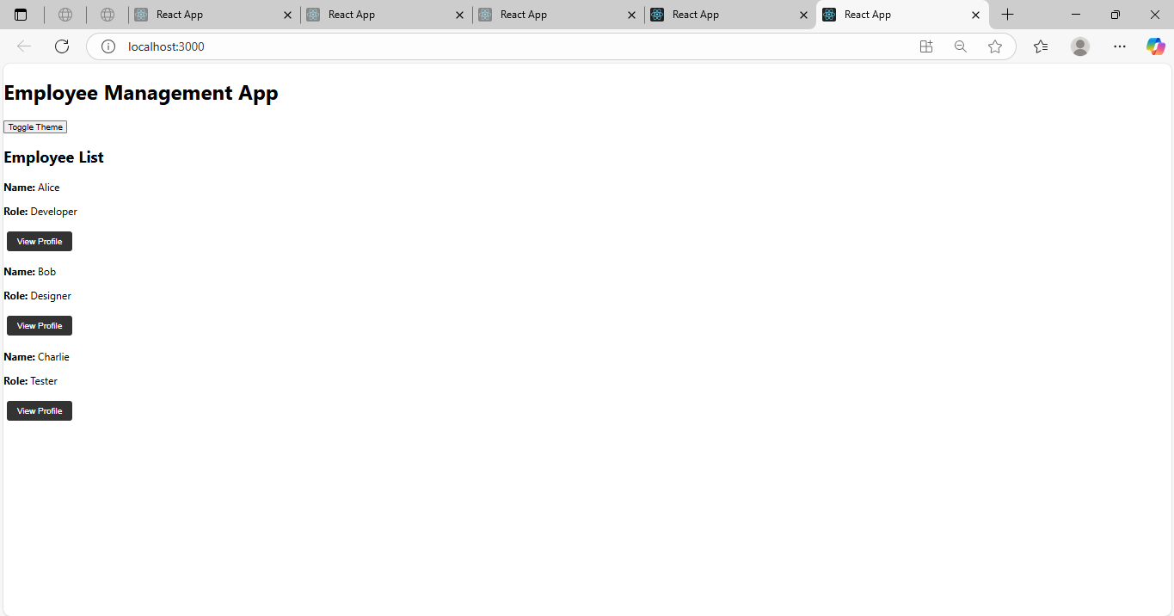

**Exercise-15:**

App.js Code:

// App.js

import React from "react";

import ComplaintRegister from "./ComplaintRegister";

function App() {

  return (

    <div className="App">

      <ComplaintRegister />

    </div>

  );

}

export default App;

ComplaintRegister.js Code:

// ComplaintRegister.js

import React, { useState } from "react";

function ComplaintRegister() {

  const [name, setName] = useState("");

  const [complaint, setComplaint] = useState("");

  const handleSubmit = (e) => {

    e.preventDefault();

    const referenceNumber = Math.floor(Math.random() * 1000000);

    alert(

      `Complaint submitted successfully!\n\nEmployee: ${name}\nComplaint: ${complaint}\nReference Number: ${referenceNumber}`

    );

    // Clear form

    setName("");

    setComplaint("");

  };

  return (

    <div style={{ padding: "20px", fontFamily: "Arial" }}>

      <h2>📝 Raise a Complaint</h2>

      <form onSubmit={handleSubmit}>

        <div>

          <label>Employee Name:</label><br />

          <input

            type="text"

            value={name}

            required

            onChange={(e) => setName(e.target.value)}

            placeholder="Enter your name"

          />

        </div>

        <br />

        <div>

          <label>Complaint:</label><br />

          <textarea

            value={complaint}

            required

            onChange={(e) => setComplaint(e.target.value)}

            placeholder="Describe your complaint"

            rows={4}

            cols={40}

          />

        </div>

        <br />

        <button type="submit">Submit Complaint</button>

      </form>

    </div>

  );

}

export default ComplaintRegister;

Output:

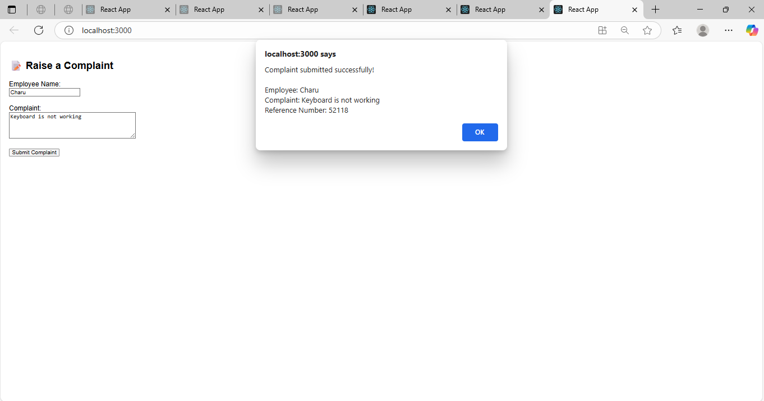

**Exercise-16:**

Register.js Code:

import React, { useState } from "react";

function Register() {

  const [formData, setFormData] = useState({

    name: "",

    email: "",

    password: "",

  });

  const [errors, setErrors] = useState({});

  const handleChange = (e) => {

    const { name, value } = e.target;

    setFormData((prev) => ({ ...prev, [name]: value }));

  };

  const validate = () => {

    const newErrors = {};

    if (formData.name.trim().length < 5) {

      newErrors.name = "Name should have at least 5 characters.";

    }

    if (!formData.email.includes("@") || !formData.email.includes(".")) {

      newErrors.email = "Email must include '@' and '.'.";

    }

    if (formData.password.length < 8) {

      newErrors.password = "Password must have at least 8 characters.";

    }

    return newErrors;

  };

  const handleSubmit = (e) => {

    e.preventDefault();

    const validationErrors = validate();

    if (Object.keys(validationErrors).length > 0) {

      setErrors(validationErrors);

    } else {

      alert("Form submitted successfully!");

      console.log(formData);

      setFormData({ name: "", email: "", password: "" });

      setErrors({});

    }

  };

  return (

    <div style={{ padding: "20px" }}>

      <h2>Register Form</h2>

      <form onSubmit={handleSubmit}>

        <div>

          <label>Name: </label>

          <input

            type="text"

            name="name"

            value={formData.name}

            onChange={handleChange}

          />

          {errors.name && <p style={{ color: "red" }}>{errors.name}</p>}

        </div>

        <div>

          <label>Email: </label>

          <input

            type="text"

            name="email"

            value={formData.email}

            onChange={handleChange}

          />

          {errors.email && <p style={{ color: "red" }}>{errors.email}</p>}

        </div>

        <div>

          <label>Password: </label>

          <input

            type="password"

            name="password"

            value={formData.password}

            onChange={handleChange}

          />

          {errors.password && <p style={{ color: "red" }}>{errors.password}</p>}

        </div>

        <button type="submit">Register</button>

      </form>

    </div>

  );

}

export default Register;

App.js Code:

import React from "react";

import Register from "./register";

function App() {

  return (

    <div className="App">

      <Register />

    </div>

  );

}

export default App;

Output:

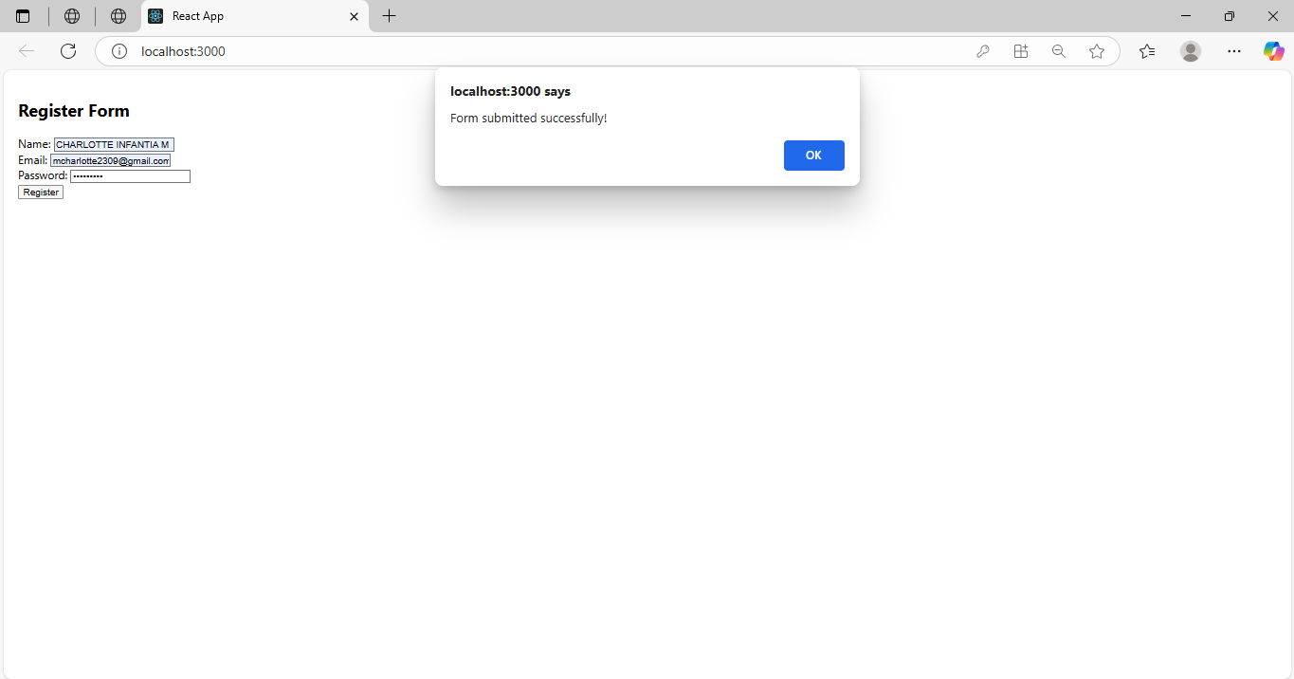

**Exercise-17:**

App.js Code:

import React from "react";

import Getuser from "./Getuser";

function App() {

  return (

    <div className="App">

      <Getuser />

    </div>

  );

}

export default App;

GetUser.js Code:

import React, { Component } from "react";

class Getuser extends Component {

  constructor() {

    super();

    this.state = {

      user: null,

    };

  }

  async componentDidMount() {

    try {

      const response = await fetch("https://api.randomuser.me/");

      const data = await response.json();

      this.setState({ user: data.results[0] });

    } catch (error) {

      console.error("Error fetching user:", error);

    }

  }

  render() {

    const { user } = this.state;

    if (!user) {

      return <div>Loading user data...</div>;

    }

    return (

      <div style={{ padding: "20px", textAlign: "center" }}>

        <h2>User Information</h2>

        <p><strong>Title:</strong> {user.name.title}</p>

        <p><strong>First Name:</strong> {user.name.first}</p>

        <img src={user.picture.large} alt="User" style={{ borderRadius: "50%" }} />

      </div>

    );

  }

}

export default Getuser;

Output:

